# Understanding the biological function of a protein using structural bioinformatics

**Abstract** Structural bioinformatics studies molecular structures and interactions to explain the function of a biological molecule in question, and when necessary find a way to block this function for medicinal purposes. In this workshop, we will combine homology modeling to create a model of a protein, and molecular docking to study interactions of an important protein-protein complex (found in Myeloma cells) with DTP3 – a pharmacologically potent drug molecule that disrupts the protein complex and improves survival rates. Bring your own laptop and have USCF Chimera installed!

Download (from: <https://www.cgl.ucsf.edu/chimera/download.html>) and install USCF Chimera program, which we will be using in this workshop.

There is a great number of software for molecular modeling, each has its advantages and focused areas of applications. USCF Chimera (from now on simply 'Chimera') is my first choice, because it is free software with extremely broad range of functionalities. These include: interactive visualization and analysis of molecular structures and related data, including density maps, supramolecular assemblies, homology modeling, sequence alignments, docking results, trajectories, conformational ensembles, ability to generate high-quality images and animations, etc.

## Objectives of the workshop:

1. Introduce yourself to Chimera – a molecular modeling program of general applicability.

2. Learn about homology (comparative) modeling using Modeller functionality of Chimera (<https://salilab.org/modeller/>), and gain a better understanding of protein structure-functionality relationship. To perform homology modeling with Modeller you need to obtain a license-key from <https://salilab.org/modeller/registration.html>.

3. Learn to analyze protein-protein complexes and introduce yourself to protein-protein docking approaches.

4. Learn to perform protein/small molecule docking using AutoDock Vina (<http://vina.scripps.edu/>) functionality of Chimera, and to analyze the docking results.

Files for this workshop can be found on:

<https://github.com/annareym/SBW_2019_workshop>

## General introduction

In this workshop we will be investigating a real research problem of a GADD43β-MKK7 protein-protein complex. GADD45β protein is selectively expressed in Myeloma cells. Multiple myeloma is the second most common type of a blood cancer, which accounts for 15% or all blood cancers. Expression of GADD45β is strongly correlated with higher mortality rates of multiple myeloma patients. GADD45β is believed to deactivate the JNK kinase, MKK7, by forming a protein-protein complex. The formation of the complex impedes the cellular apoptotic programs and enables the survival of multiple myeloma cancer cells. DTP3 – a small peptide molecule (Ac-D-Tyr-D-Arg-D-Phe-NH2) is shown experimentally to inhibit the GADD45β/MKK7 complex formation. DT3P is able to restore the MKK7 activation, thereby promoting selective cell death of GADD45β-overexpressing cancer cells.

A combination of enzymatic MS foot-printing and diazirine-based chemical cross-linking MS strategies were applied to study the interactions between GADD45β and MKK7 kinase, and between DTP3 and MKK7. Through this analysis it was found the regions that are involved in the interactions between GADD45β and MKK7 proteins include GADD45β loop 2 (region 103-117) and MKK7 kinase enzymatic pocket (the pocket hosting the ATP molecule, residues 6-9,42-46,72-80,94-100,149-157). The DTP3 peptide interferes with the complex formation by interacting with two MKK7 regions, residues 113-136 and 259-274. We will use structural bioinformatics to understand and verify the mechanism of action of DTP3. If the time permits we will try to rationalize why DTP3 has similar anticancer potency to the clinical standard, bortezomib, but more than 100-fold higher cancer cell specificity.

**NB:** I recommend creating a separate folder on your computer, dedicated to this workshop.

**Part 1: Using USCF Chimera**

Let's take a few moments to introduce ourselves to USCF Chimera. Chimera allows opening of a wide range of file types, to name a few: pdb, mol2, Gaussian output files, Gromos87 [gro] files, fasta, Electron density maps [edm] files, etc. You can also conveniently fetch a pdb file from Protein Data bank or other structural databases by clicking 'Fetch by ID'. You can also save and later open a Chimera session to preserve your progress. We will use this option today at the end of the workshop to allow you to return to the material later. You save a structure files in either pdb or mol2 format, and make beautiful figures for a publication. For further details, see Chimera tutorials webpage.

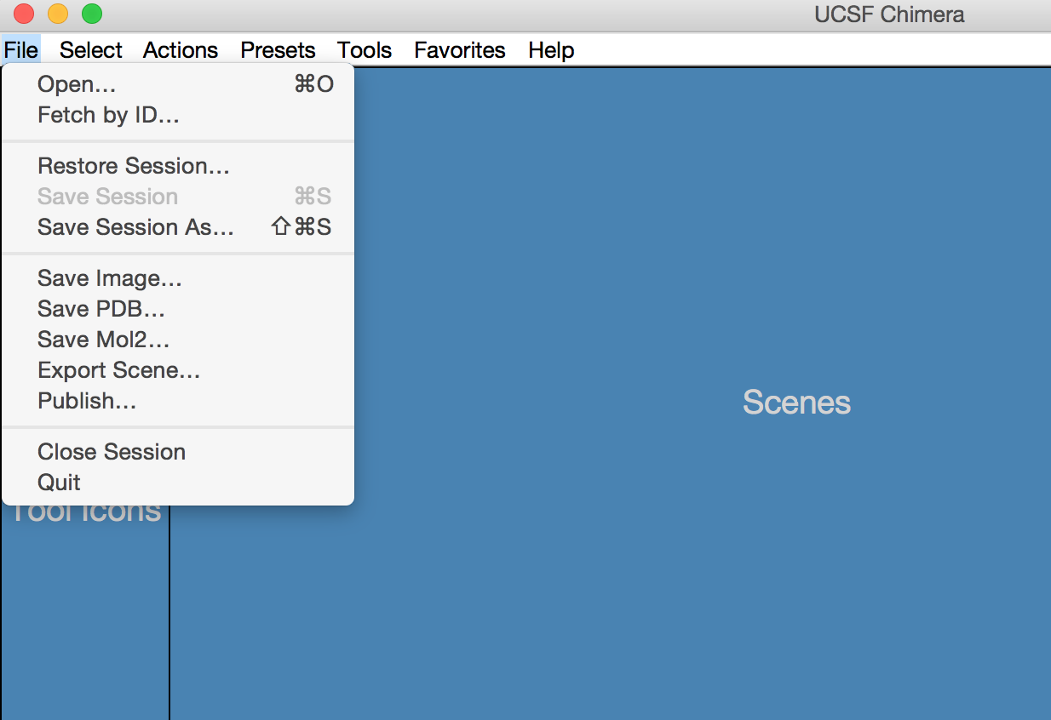

Let's open a structure of JNK1 kinase with PDB ID: 4UX9. So, click 'File', then 'Fetch by ID', then make sure that you will be fetching from PDB database and type '4UX9' in the empty field. A tetramer structure will appear on your screen, use your mouse or track pad to rotate and move the structure. JNK1 kinase was co-crystalized with ANP (slow hydrolysable analog of ATP), and we will try to understand the interactions between ANP ligand and JNK1 protein. To do that let's focus on just one protein chain and remove the rest. For that click 'Select' then 'Chain' and select 'A'. You will see one protein chain will be selected. Then click 'Select' again and choose 'Invert (selected models)'. To remove the selected parts of the structure click 'Actions', then 'Atoms', then 'Delete'. You will see that only one protein chain will remain on your screen, chain A, which we will continue working with. Let's refocus our working area by clicking 'Actions' and then 'Focus'. You can have different depiction styles for your molecular system. You can make all atoms being visible by clicking 'Actions' —> 'Atoms' —> 'Show', and make ribbons disappear by clicking 'Actions' —> 'Ribbons' —> 'Hide'. You can show atoms with 'balls and sticks' or 'wire' representations; you can add protein surface, with different level of transparency and atom and residues labels. All this can be done though 'Actions' menu.

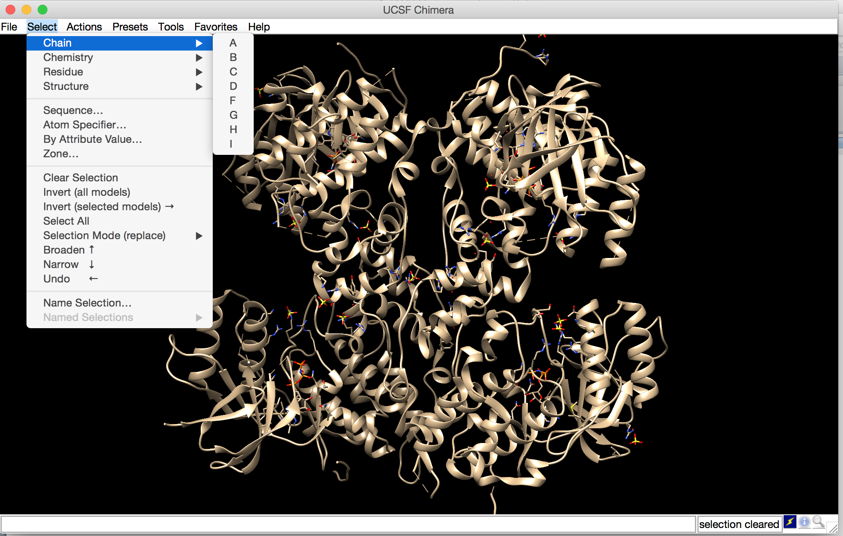

Let us now look into the protein ANP interactions. Click 'Tools' then 'Structure Analysis' and 'Find Clashes/Contacts'. The 'Tools' menu of Chimera contains a lot of interesting feature and we will use some of them today for homology modeling and docking. If you want to learn more, go to Chimera tutorials webpage.

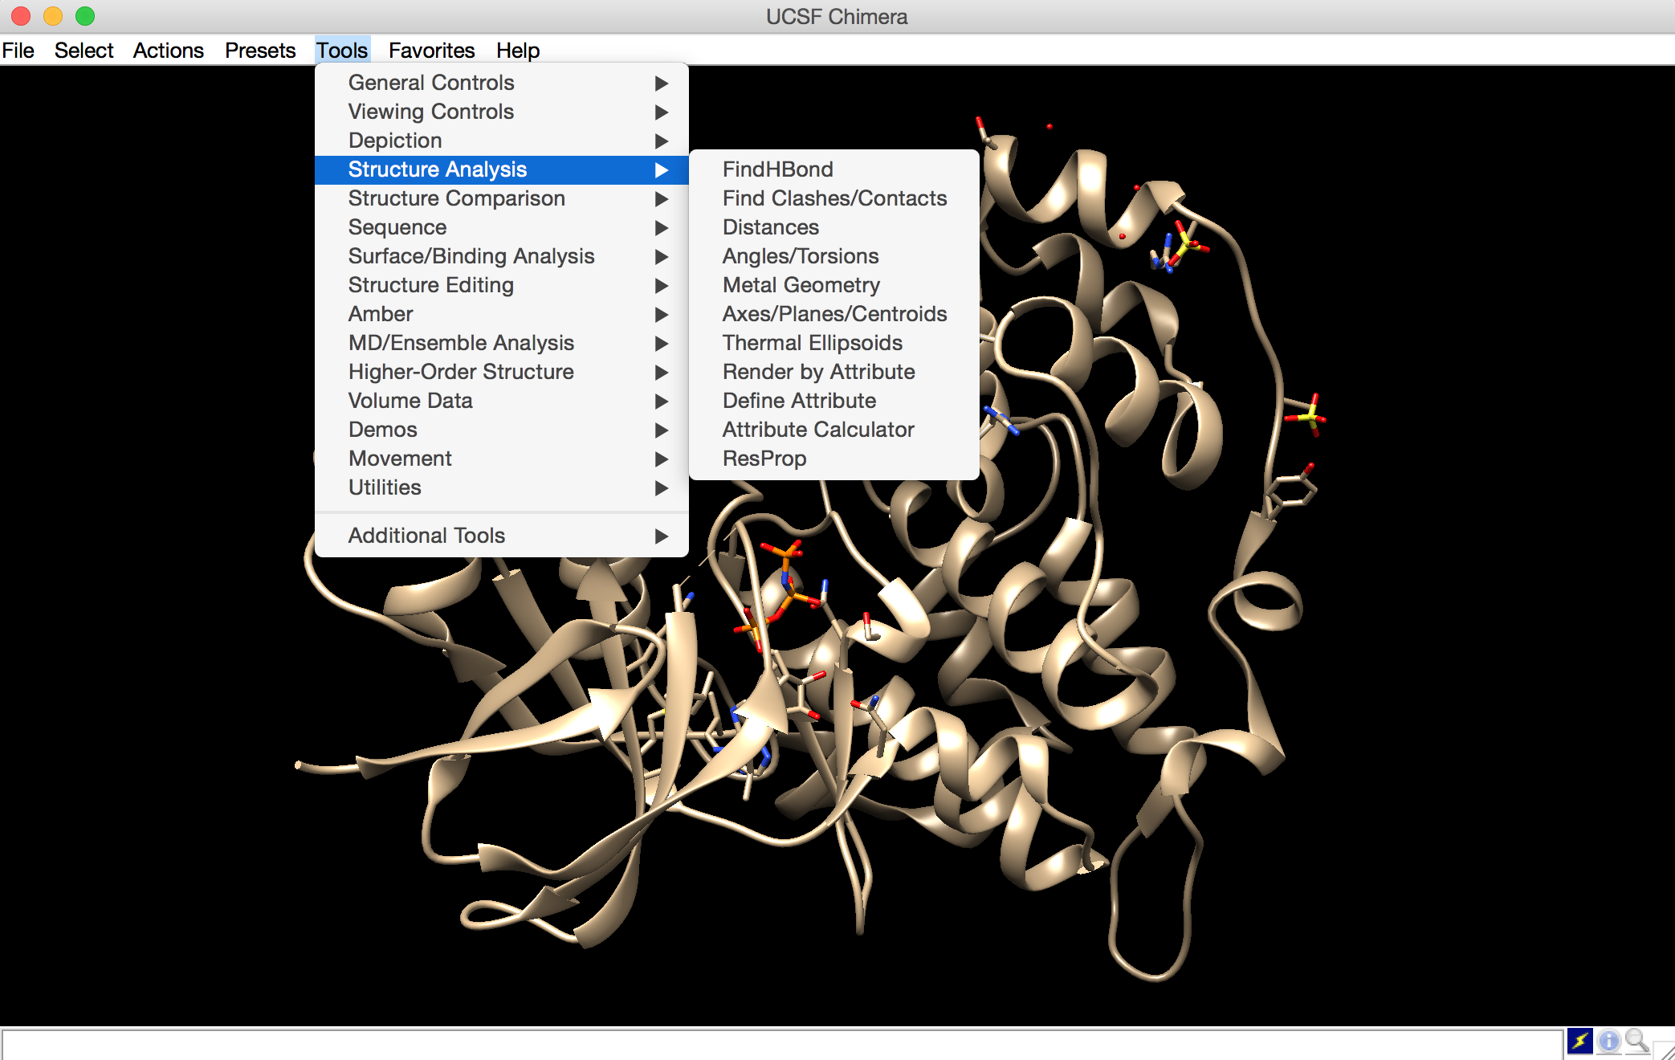

After we clicked on 'Find Clashes/Contacts' a pop-up window will appear, move it with your mouse or track pad a little to the side, we have to be able to work in both main window and 'Find Contacts/Clashes' window in parallel. As we are interested in the contacts between ANP and the protein, we will first select ANP from 'Select' —> 'Residue' —> 'ANP' menu as the first set of atoms. In 'Find Contacts/Clashes' window click 'Designate' to tell the program to choose 31 atoms of ANP as the first set of atoms. Then to select the protein go to 'Select' —> 'Structure' —> 'Protein' and in 'Find Contacts/Clashes' window check 'Second set of designated atoms' and click 'Designate selection as second set', which will account for 2770 atoms. Then in in 'Find Contacts/Clashes' window among 'Clash/Contacts parameters' select option 'Contacts'; in 'Treatment of Clash/Contact atoms' check 'Draw pseudobonds of color', 'Select', 'If endpoint atom hidden, show endpoint residue', and 'Write information to file' and click 'OK' or 'Apply'. You will be asked to provide a file name and file location, where to the information about the contacts between ANP and JNK1 kinase will be written. Also, you will see that a part of protein was selected. To understand the interactions better, lets depict the selected part of the protein with atoms and hide ribbons. Use 'Actions' menu to do that. Be aware that the result of this analysis only shows the proximity of the two atom sets, which is not necessarily has a chemical meaning.

Alternatively, we can find hydrogen bonds between ANP and the kinase by clicking 'Tools' —> 'Structure Analysis' —> 'FindHBonds'. To restrict the analysis to only H-bonds between the protein and ANP, let's select the ligand as we did previously and in 'H-bonds parameters' menu check 'Only find H-bonds' 'with exactly one end selected', and 'Write information to file'. Click 'apply' and provide a file name and file location. I recommend giving the bonds-information files an extension 'txt', e.g. 'hbond_analysis.txt' to be able to open them later with a text editor program of your choice. We will see that ANP has a number of interesting H-bond contacts with the protein residues. These contacts explain the selective binding of ANP to this particular pocket on the surface of JNK1 kinase. Spend a moment to understand these interactions before moving on to the next stage.

You can also the Chimera session to be able to return to the analysis later if needed. Click 'File' —> 'Save Session as' and name the session, then close session to begin a new one: 'File' —> 'Close Session'.

**Part 2: Homology modeling**

It is quite often that a structure of a protein in question has not yet been solved experimentally: by means of X-ray crystallography, NMR or Cryo-electron microscopy. In this situation we can use the structural bioinformatics approach known as homology modeling or comparative modeling. This approach allows building of an atomistic model of a protein from its sequence of amino acids given that at least one structure of a related homologous protein was solved. The protein in question is named 'the target', and the homologous protein(s) – 'the template(s)'. The quality of the homology model depends on the sequence similarity between the target and the templates accessed though the sequence alignment. The sequence alignment maps the sequence of the protein target to the sequences of the templates. Homology modeling relies on the notion that evolutionarily related proteins have similar sequences and naturally occurring homologous proteins have similar 3D structures.

We will use homology modeling to design the structure of human GADD45β, which has not been solved experimentally yet, and to construct the missing regions of human MKK7 kinase. It is often that experimental structures of proteins contain missing regions, typically loops and other random coil regions. However knowledge about these regions can be crucial for understanding of the proteins' function. We will take a special care and model these regions using Modeller functionality of Chimera. Modeller is a homology-modeling program that can be used independently. For further information and Modeller tutorials visit <https://salilab.org/modeller/>. To proceed with homology modeling, we first need to download the fasta files with the amino acid sequences of human GADD45β and MKK7, from <https://www.uniprot.org/>

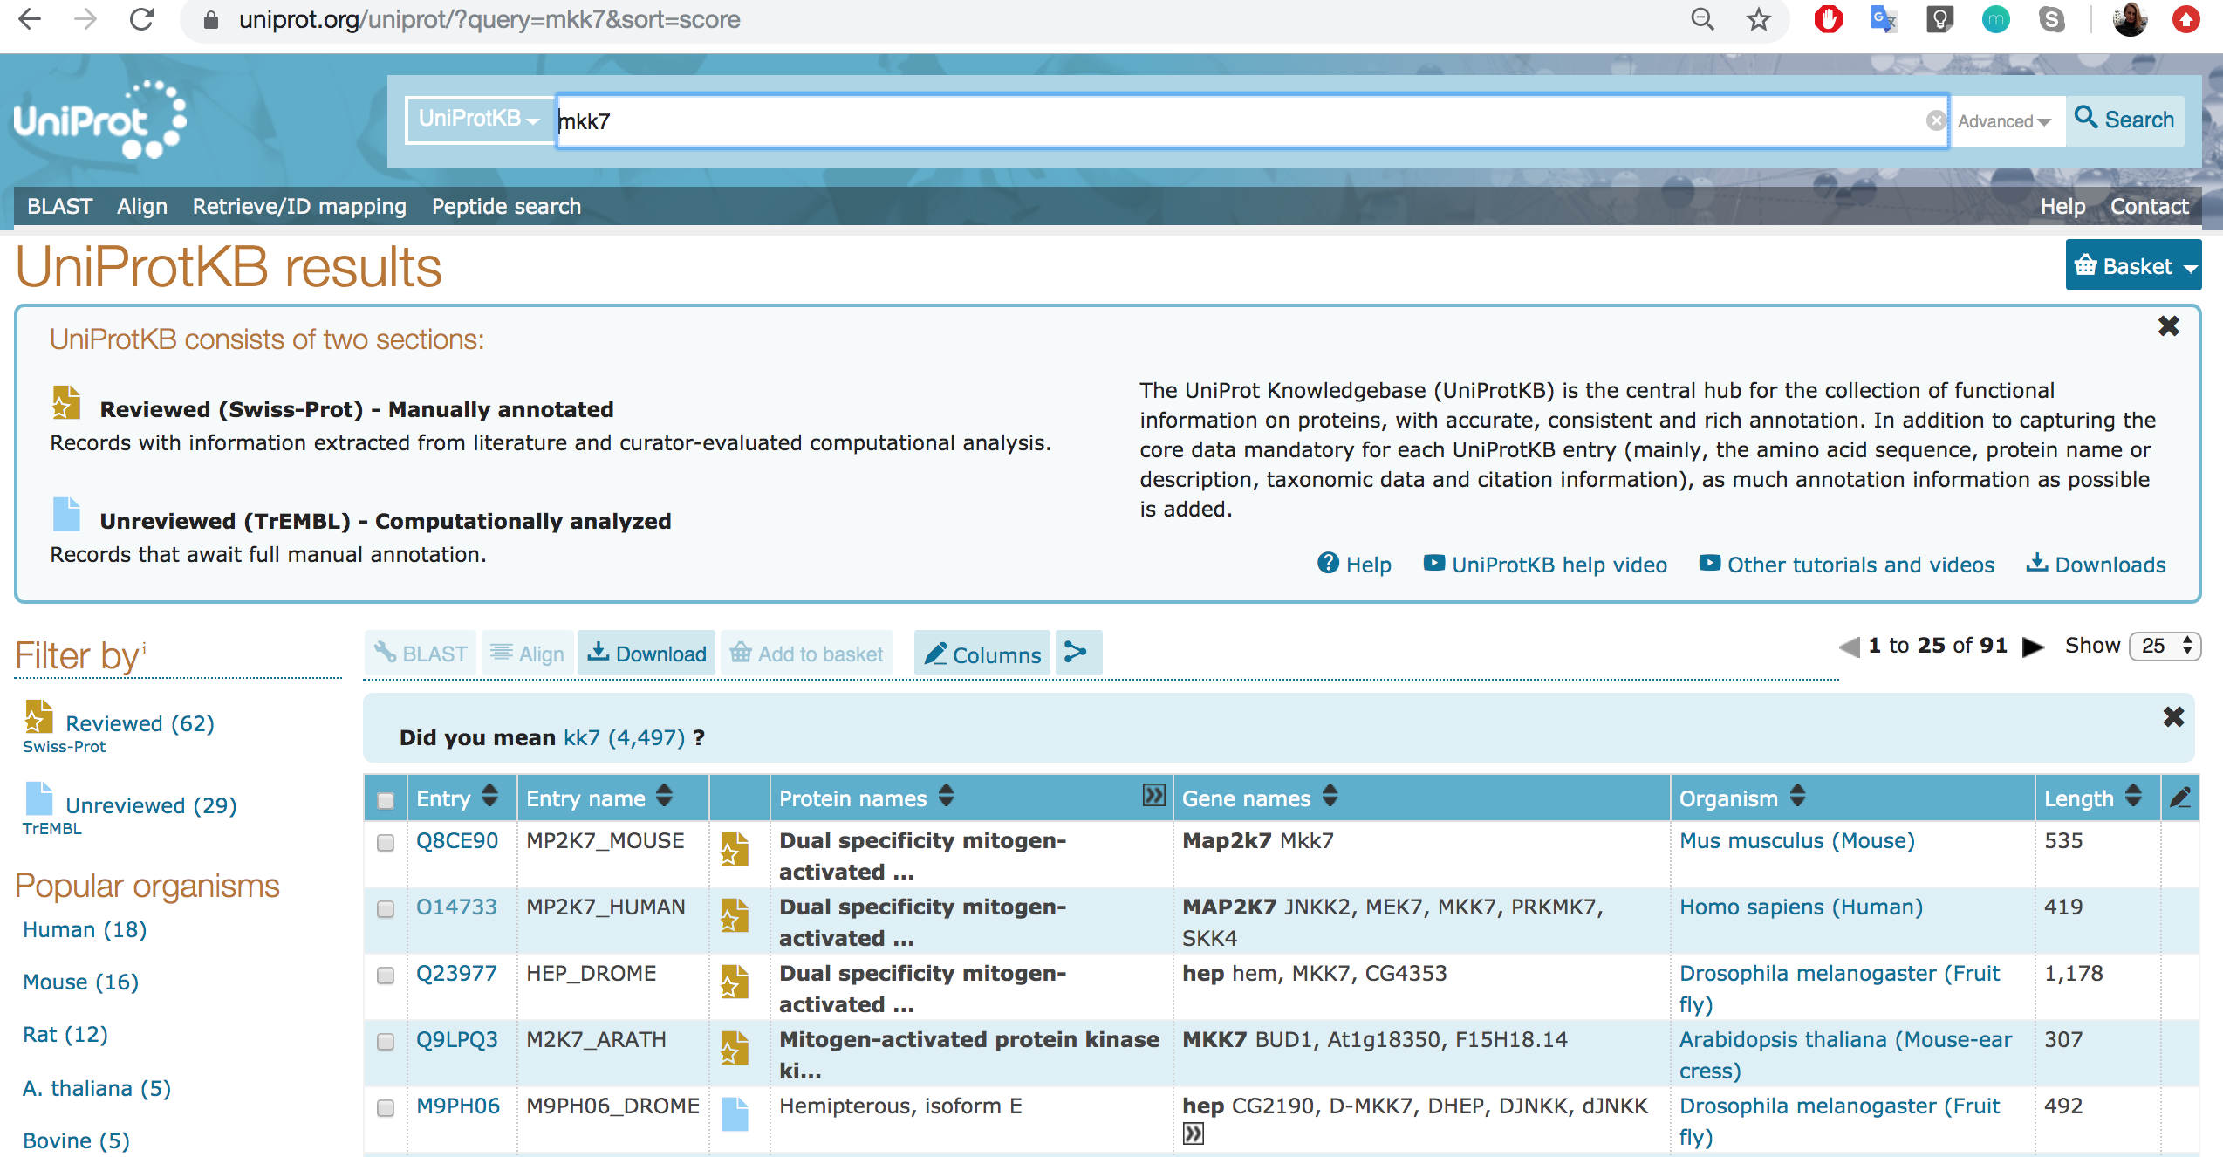

Select 'Homo sapiens' in the table and download the fasta files for the two proteins.

At this moment you will need to make sure that you have received a Modeller license-key that you have asked for in the beginning of the workshop. Let's start with the structure of GADD45β. To initiate homology modeling click on 'Tools' —> 'Sequence' —> 'Blast Protein', and in the 'Blast Protein' window select the bookmark 'Plain Text' and paste the fasta file of GADD45β. It can happen that due to some technical problems, protein blast cannot be performed. In that case, it is possible to use either another homology modeling programs or online resources, such as Swiss-Model <https://swissmodel.expasy.org/>, or  
I-Tasser <https://zhanglab.ccmb.med.umich.edu/I-TASSER/>

If, however, protein blast in Chimera works, you will receive a list of the protein structures from which you can choose several to use the templates. For GADD45β we can select two PDB files with PDB IDs 2KG4 and 3FFM. Again if protein blast did not work, you can fetch these two pdb files manually through 'File' —> 'Fetch by ID'. Let's start with 2KG4 structure, which was obtained by NMR and contains 20 slightly different models. We will select model #1 for simplicity: 'Select' —> 'Chain' —> 'A' —> '2KG4(#0.1)' and remove models #2-20 by 'Select' —> 'Invert (all models)', then 'Action' —> 'Atoms' —> 'Delete'. You will see just one protein chain left. You can now fetch 3FFM file. The two structures are two homologs of GADD45β: 2KG4 file corresponds to human GADD45α, and 3FFM – to human GADD45γ. Let's compare the two structures by clicking 'Tools' —> 'Structure Comparison' —> 'MatchMaker', and select one structure as 'Reference Structure' and second structure as 'Structure(s) to Match', and click 'OK'. In this case it does not matter which one you choose as the reference, but it can be important in a different situation. In the bottom left corner of Chimera main window you will see the value of RMSD. RMSD (root mean square deviation) compares positions of the proteins' Cα. In this case, we see that the RMSD value is about 3Å.

So let's proceed to the homology modeling of human GADD45β. First we will open GADD45β fasta file and in the sequence window click on 'Edit' —> 'Add sequence'. A new window will pop up 'Adding Sequence to XXX.fasta', there select the tab 'From Structure' and select first '2KG4 chain A' and click apply, repeat the procedure, but this time add the sequence of '3FFM'. Return to sequence window where now you will see 3 sequences, one from GADD45β, one from 2KG4, and one from 3FFM, and click 'Edit' —> 'Realign Sequences'. Increase number of guide-tree/HMM iterations to at least 3, and click 'apply'. We can now run homology modeling.

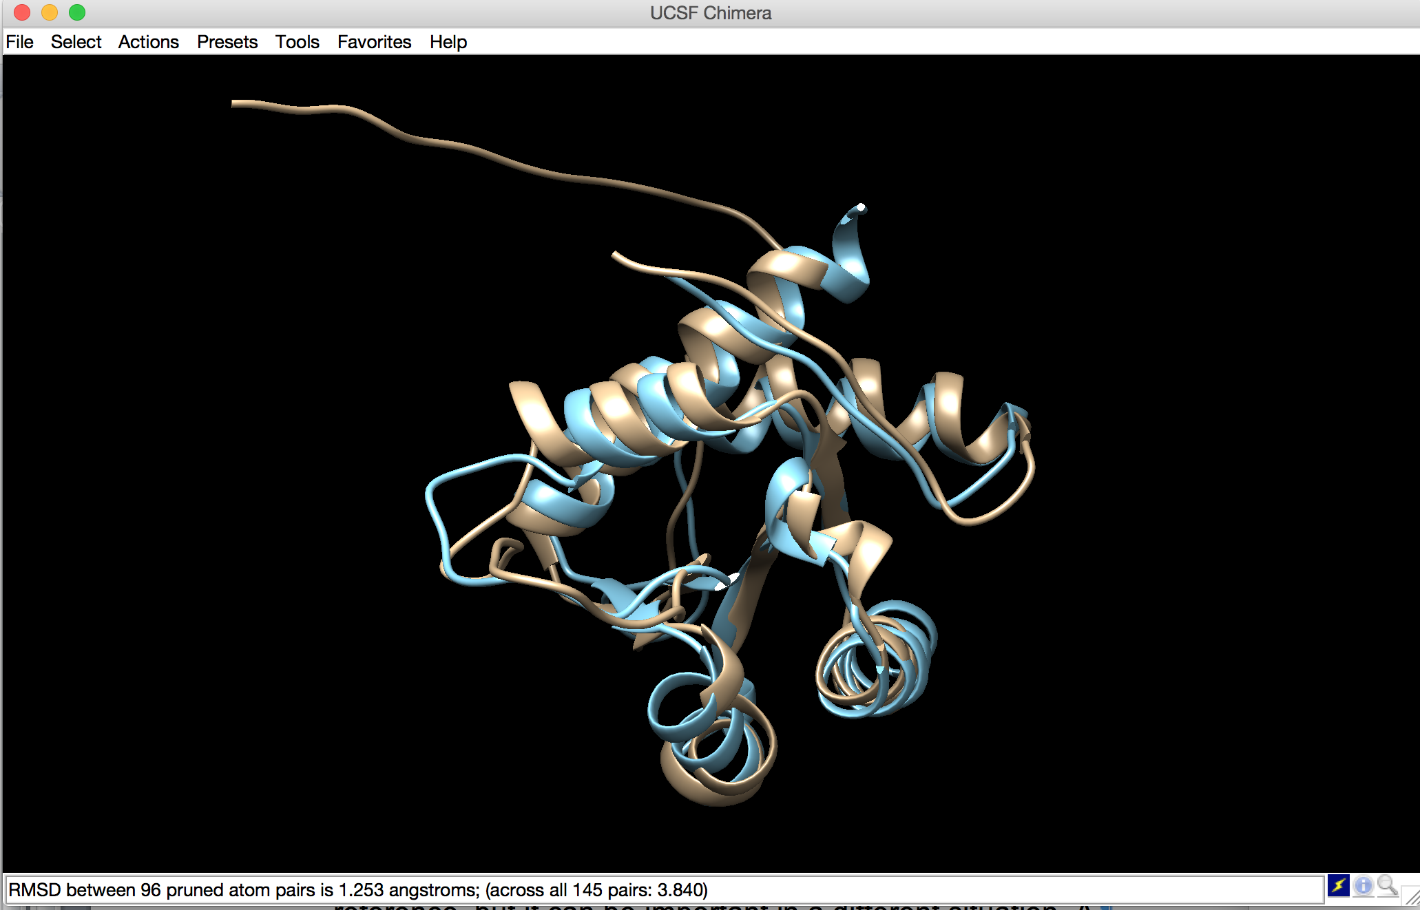

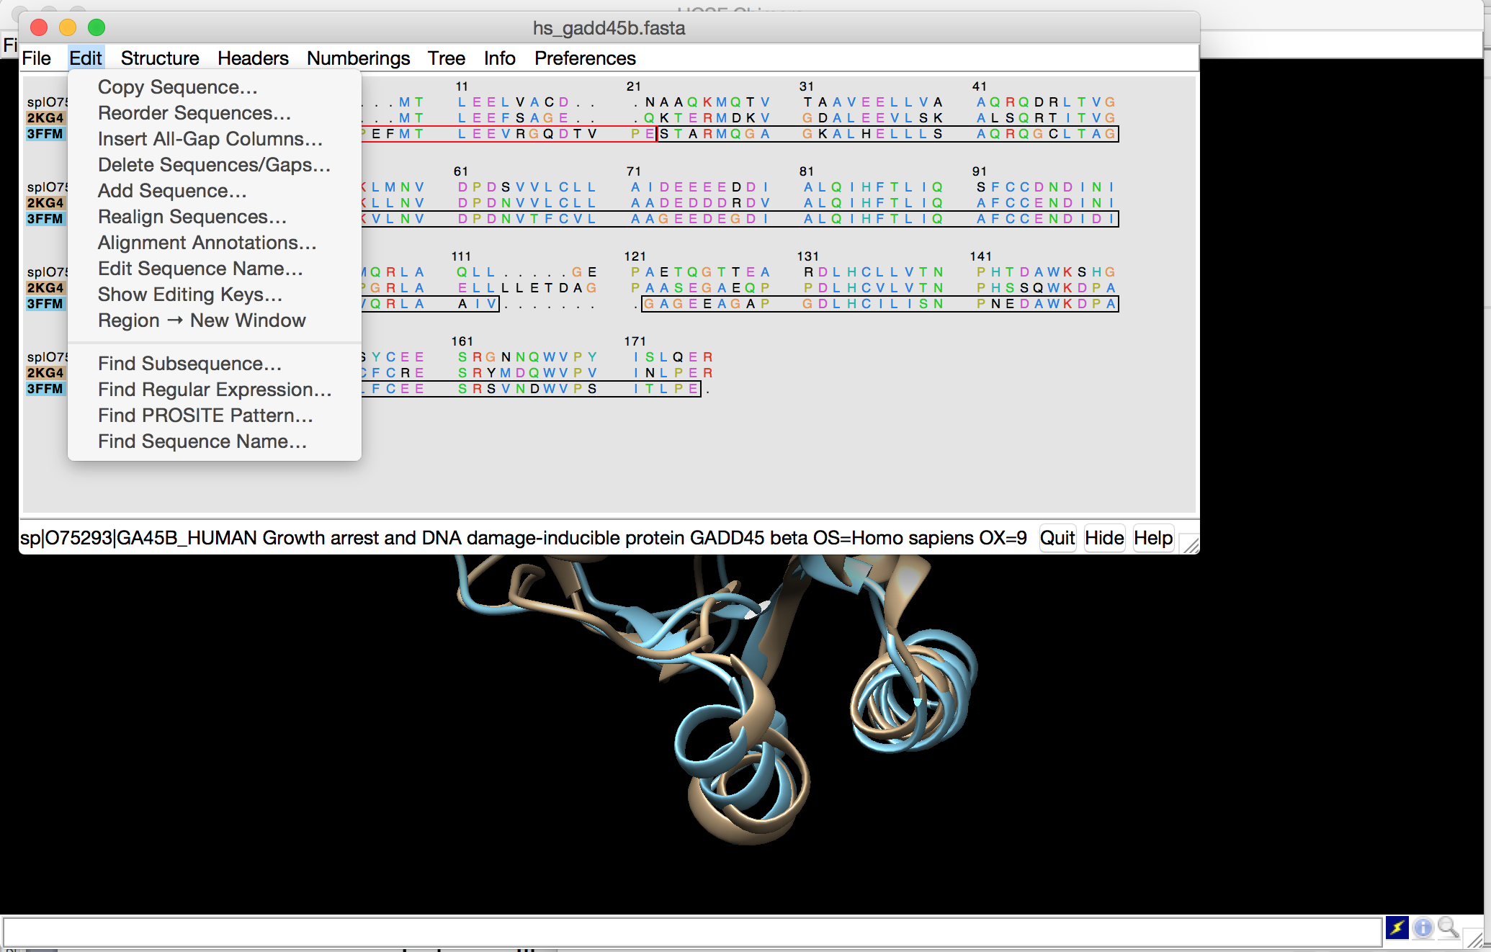

In sequence window select 'Structure' —> 'Modeller (Homology)'. In Modeller window select both 2KG4 and 3FFM as template structures. Copy-paste the license-key you have received from Modeller and check 'Build models with hydrogens' and 'Use thorough optimization'. The Modeller will result in 5 models with slightly different zDOPE score; choose the model that has the lowest score, in my case it is model #4 with zDOPE score of -0.68.

Now we will proceed with modeling of missing loops for MKK7 kinase, but before starting let's save the model structure of GADD45β protein. Click 'File' —> 'Save PDB', and select a model that you want to save, give a name and select a location.

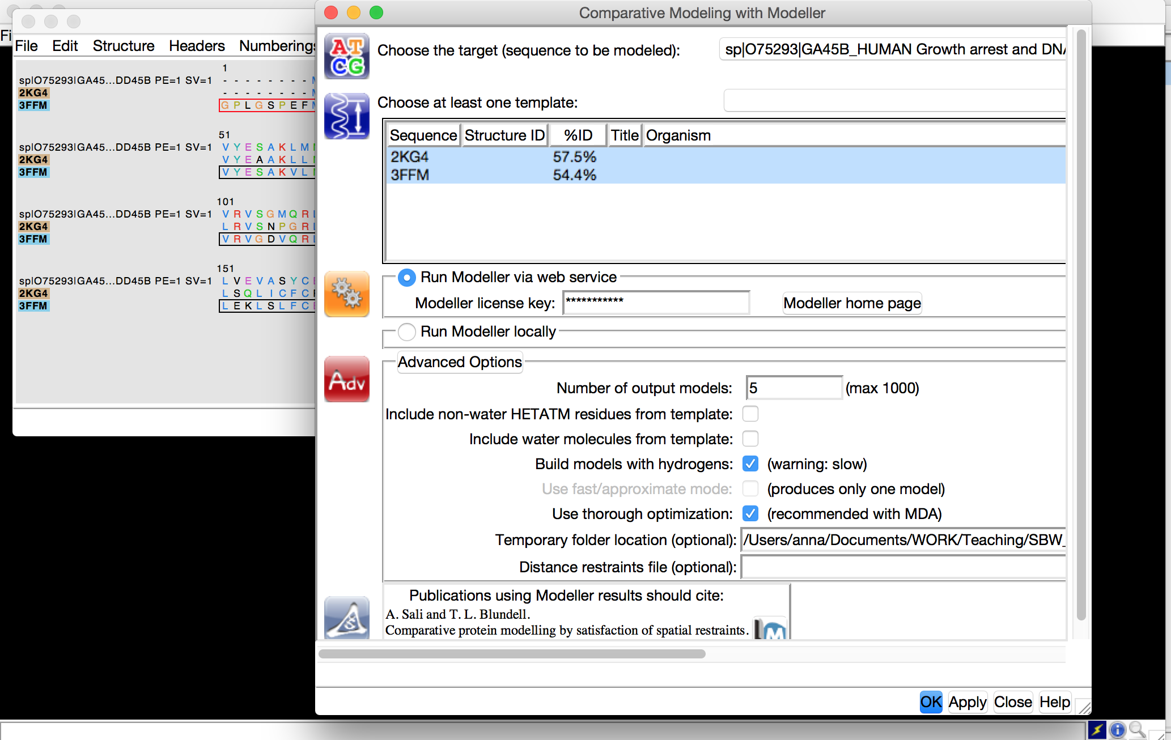

For modeling of missing loop regions of MKK7 kinase, we will start by downloading the PDB file (PDB ID: 5Y90), which contains a 1.3Å resolution crystal structure of the protein. You will notice that several proteins are overlapping, which is not very convenient. We can select which structure is displayed by opening a 'Model Panel' from 'Favorites' menu. In 'Model Panel' window you will see a list of all structures currently loaded to Chimera. You can hide the structure by unchecking the corresponding 'S'-box ('S' stands for 'show'). 'A'-box controls if the model is active and can be moved. Try to show and hide all of the structures apart from 5Y90 and refocus the view: 'Actions' —> 'Focus'. 5Y90 structure contains several water molecules and other small molecules that we will need to remove. You can use mouse and 'right click' by pointing to the object, and then 'Actions' —> 'Atoms' —> 'Delete'.

As you can see 5Y90 structure missing 2 loop regions (dashed lines), to build which click 'Tools' —> 'Structure Editing' —> 'Model/Refine loops' and now build missing loops and choose 5Y90 chain A and click 'OK'. A new window with 'Model Loops/Refine Structure' will pop up. Let's for simplicity keep all parameters default and click 'apply'. Again we will select the model with the lowest zDOPE score and save the pdb file. So now we have built two structures of human MKK7 kinase and GADD45β protein. So we can now proceed with building MKK7-GADD45β protein-protein complex.

**Part 3: Building and analyzing protein-protein complexes**

There are a number of algorithms, software, and webservers for protein-protein docking. A list of available web-based resources can be found here <http://www.vls3d.com/index.php/links/bioinformatics/protein-protein-interaction/protein-protein-docking>

In this workshop, we will use HDOCK webserver (<http://hdock.phys.hust.edu.cn/>). HDOCK is a docking approach, based on a hybrid algorithm of template-based modeling and *ab initio* free docking, and can be used for protein-protein and protein-DNA/RNA. HDOCK can accept experimental structural information as positional restraints to improve the quality of the predicted models. As was mentioned above, the experimental data suggests the interaction regions include GADD45β loop 2 (region 103-117) and MKK7 kinase enzymatic pocket (the pocket hosting the ATP molecule, residues 6-9,42-46,72-80,94-100,149-157). We will use these residues as restraints in the protein-protein docking with HDOCK.

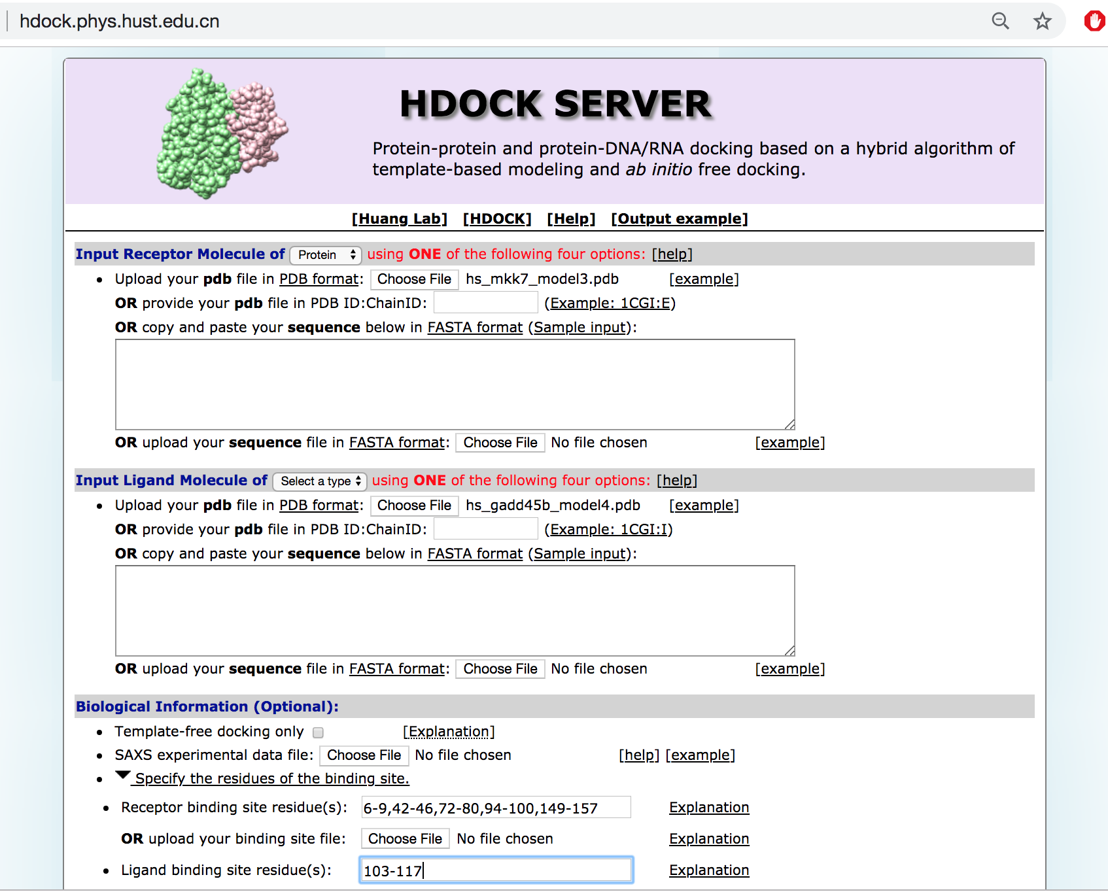

The protein-protein docking simulation will take approximately 10-15 minutes. To save the time, we will proceed with the MKK7-GADD45β complex model that has been computed previously, following the described protocol. The structure can be found in Workshop_Files/mkk7-gadd45b_complex.pdb. Download the file and spend a few moments on understanding the protein-protein interactions stabilizing the complex using 'Tools' —> 'Structure Editing' —> 'FindHbonds' and 'Find Clashes/Contacts'.

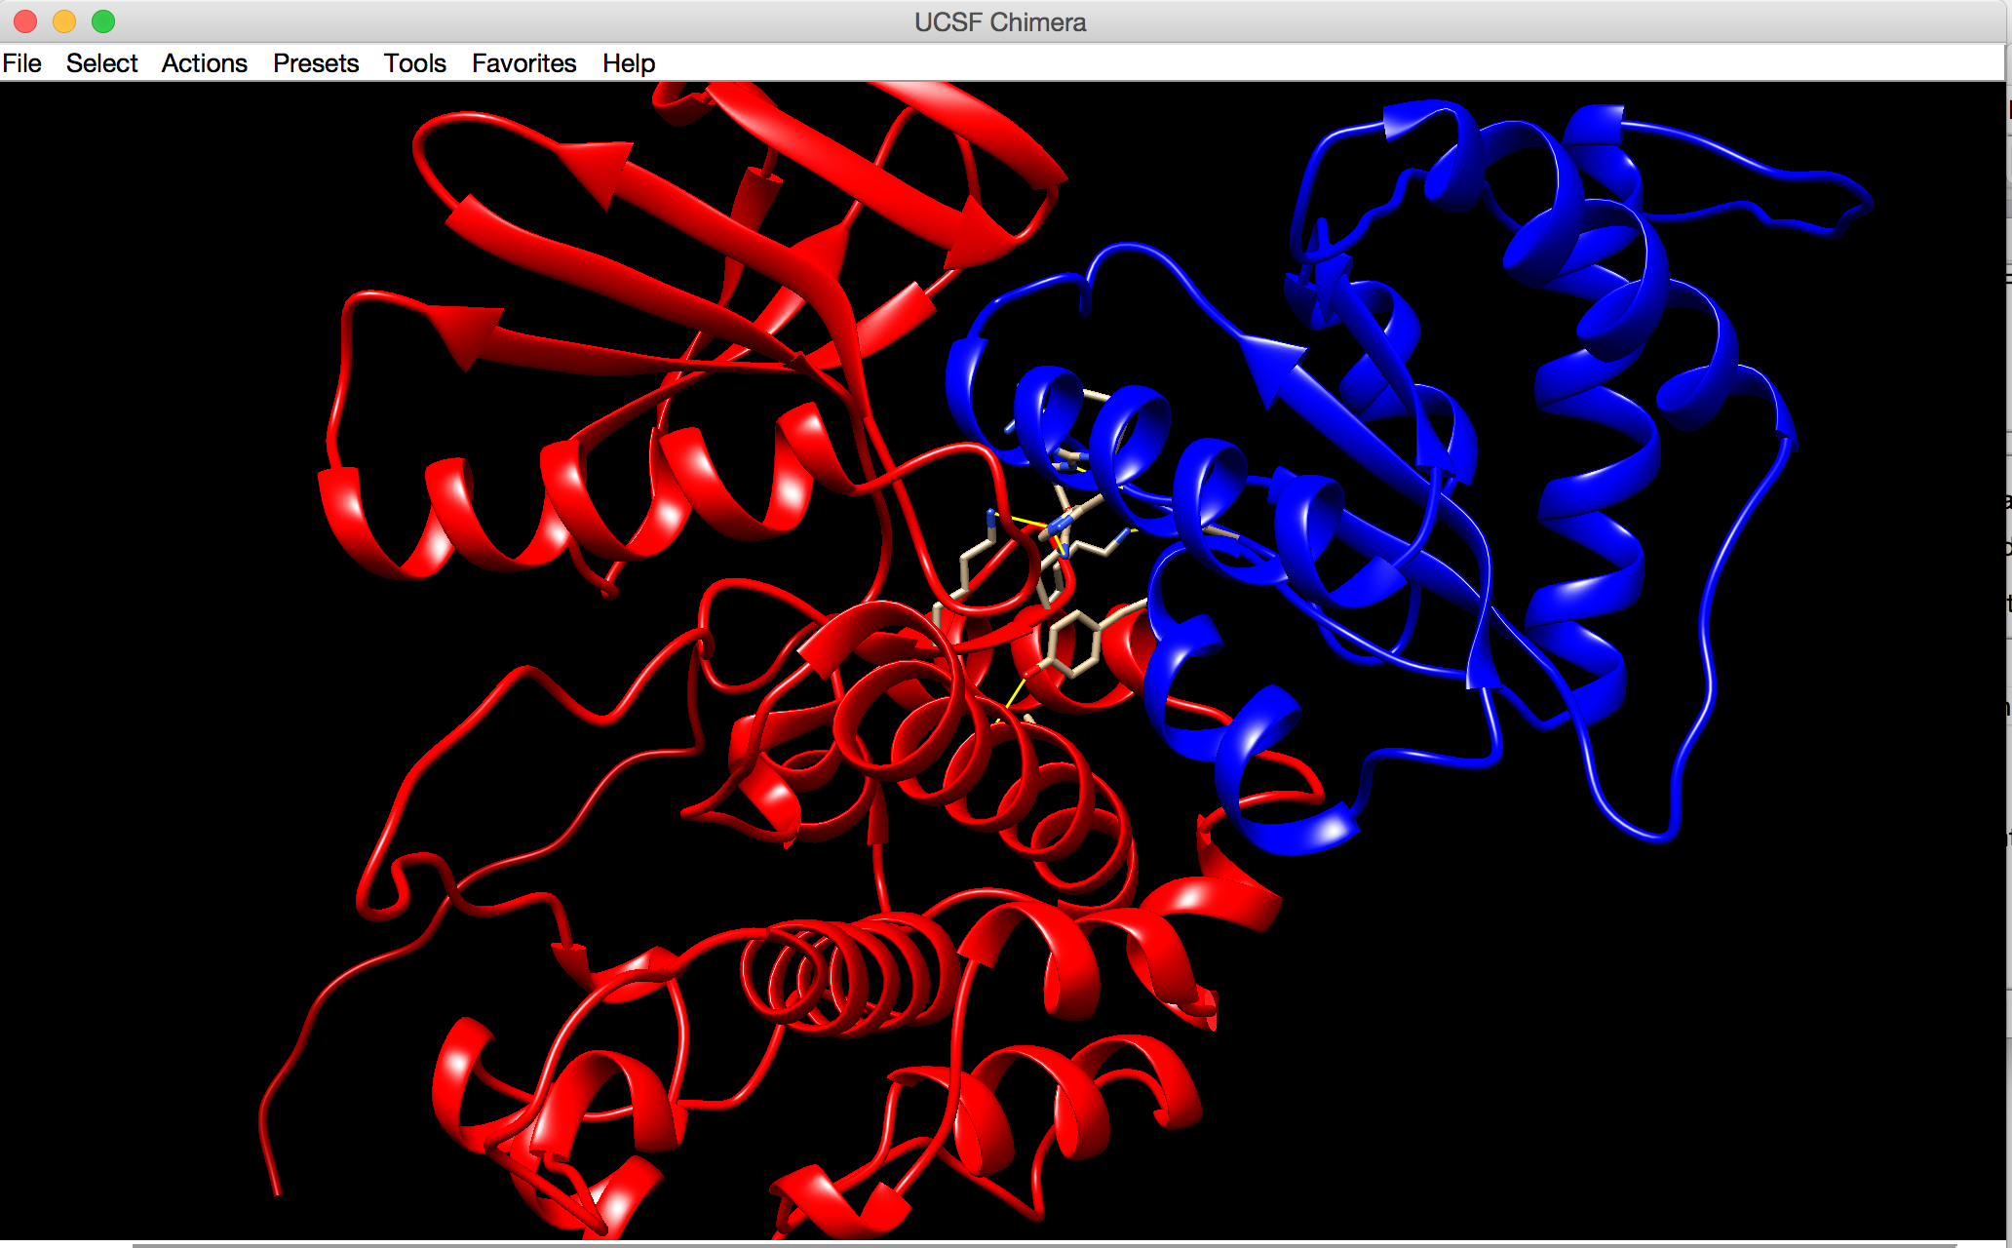

**Part 4: Protein-small molecule docking with AutoDock Vina. Why is DTP3 molecule a potent drug against multiple myeloma?**

DTP3 is a small peptide molecule (Ac-D-Tyr-D-Arg-D-Phe-NH2), was recently shown experimentally to inhibit the GADD45β/MKK7 complex formation. Researchers found that DTP3 interacts with two peptides of MKK7 kinase (regions 113-136 and 259-274); in figure below these regions are colored yellow. As we can see these two regions are in close proximity to the protein-protein interface. But we cannot be sure unless we perform the docking and confirm that DTP3 indeed prefers to bind in the area and potentially interact with the MKK7 residues involved in the contacts with GADD45β protein.

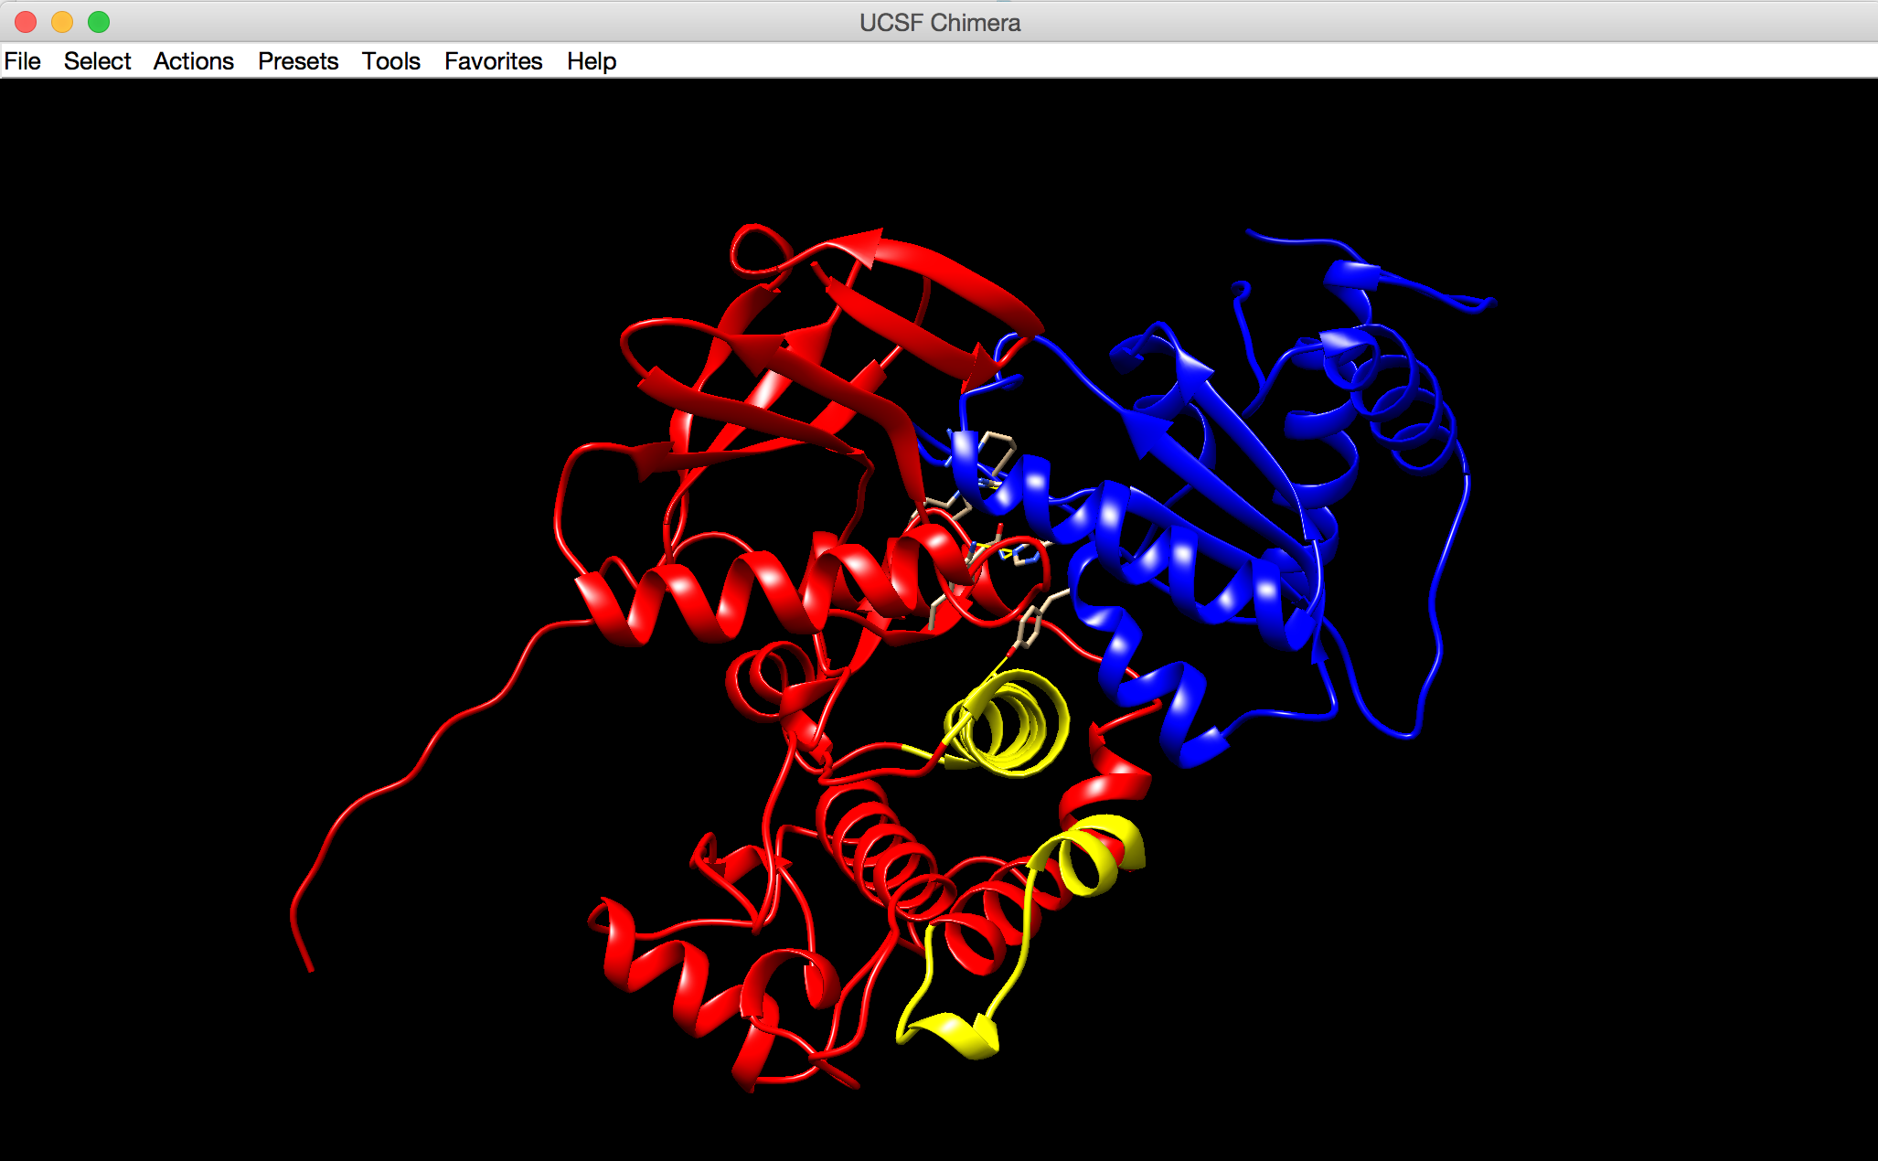

To initiate docking simulations we have to introduce and prepare DTP3 molecule. For that let's use SMILES (simplified molecular-input line-entry system, a way of representing a 3D structure of a molecule by a string of text) of DTP3:

(CC(N[C@H](CC1=CC=C(O)C=C1)C(N[C@H](CCCNC(N)=N)C(N[C@H](CC2=CC=CC=C2)C(N)=O)=O)=O)=O).

Go to 'Tools' —> 'Structure Editing' —> 'Build Structure'. In 'Build Structure' window, select 'Start Structure' on the top and 'Add' 'SMILES string', and name residue DTP3, click apply. A small peptide molecule will appear on main Chimera screen, ready to be docked to MKK7. To initiate docking click 'Tools' —> 'Surface/Binding Analysis' —> 'AutoDock Vina'. Select the center and the dimensions describing the region where the docking will be performed. This region (docking grid) should encompass the MKK7 regions, which were experimentally confirmed to interact with DTP3. One suggestion can be a box with center coordinates: X=-30, Y=10, Z=-5; and box dimensions: 40, 30 and 26. Keep in mind the bigger the docking grid, the longer the time of the docking time. NB: Before starting the docking simulation, delete the atoms corresponding to GADD45β, as it will create unnecessary steric clashes for the docking. The remaining MKK7 molecule is considered to be a receptor, and DTP3 is a ligand.

A docking calculation can take from a few minutes to half an hour, depending on the functioning capacity of AutoDock Vina webserver. Be patient! Once the docking simulation is over a window with the results will appear. In the docking results window you will a list of DTP3 docked poses. Each pose was assigned a docking score (an empirical value expressing how well a docked molecule is interacting with its receptor) and an RMSD value, telling the user how different are the resulting docked poses.

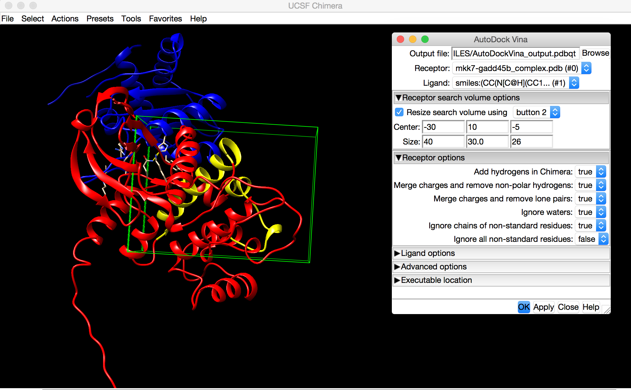

As you can see there are two preferential binding spots for DTP3 in the defined receptor grid. Both locations allow DTP3 to interact with the experimentally identified regions of MKK7 kinase (regions in yellow). However a bigger docked poses cluster is located in the interface between GADD45β and MKK7. To see that open the GADD45β-MKK7 complex structure again. Let's now look closer into what kind of interactions the best docked pose produces that can potentially intervene with the binding of GADD45β protein. If due to lack of time you would like to skip the actual docking simulation, you can open the results from (WORKSHOP_FILES/ AutoDockVina_output.ligand.pdbqt) by clicking 'Tools'—>'Surface/Binding Analysis' —> 'ViewDock.'

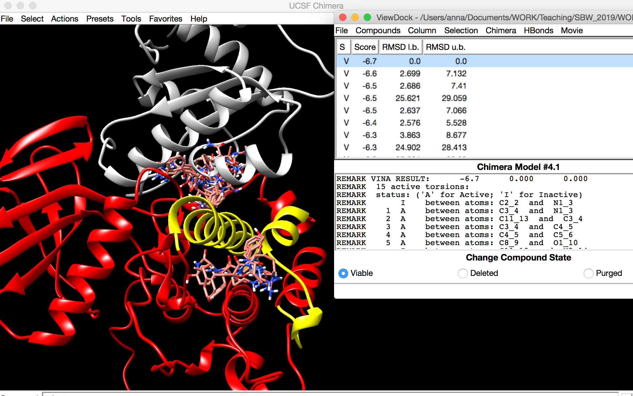

The best binding pose of DTP3 (the pose with the lowest score) is interacting with three residues of MKK7 kinase, Tyr76, Lys119 and Gln154. Are these the residues that were involved in intra-molecular interactions in GADD45β-MKK7 complex? Use 'FindHBond' analysis to locate these interactions, make sure you select DTP3 and choose 'Only find H-bonds' 'with exactly one end selected'. So the DTP3 molecule is not just binding in the very same spot on the MKK7 surface as GADD45β protein but also interacts via the same kinase residues, in this way blocking the binding of GADD45β and leaving its ATP binding domain free.

Don't forget to save Chimera session if you would like to return to the workshop!

**Bonus: Making beautiful figures**

Presenting your results is very important in scientific community. Chimera can help you create beautiful figures that will attract attention. So let's try to visualize our results in a best way possible. Let's first change some colors. Select the MKK7 chain and color it in one color, e.g. 'cornflower blue'. You can select a color from 'Actions' —> 'Color' —> 'All options...' To color a selected molecule, you can select 'All of the above' in 'Color Actions' window and choose the color. Now let's select the GADD45β chain and color it in 'forest green'. The color of the background should be white (select 'Background' in 'Color Actions' before choosing 'white'). Now let's add some tricks, click 'Favorites' —> 'Side View' and select 'Effects' bookmark. In 'Effects' check 'depth cueing' and choose white color by clicking onto a small box, and 'silhouettes' and choose color black. We are ready to make a figure: 'File' —> 'Save Image' and provide name for the file, choose appropriate image dimensions by altering height and width, resolution, and check 'transparent background' and click 'save'. You can even create a zoom-in figure showing DTP3 and MKK7 interactions, explaining why this peptide can disrupt GADD45β-MKK7 complex. Let your imagination decide!

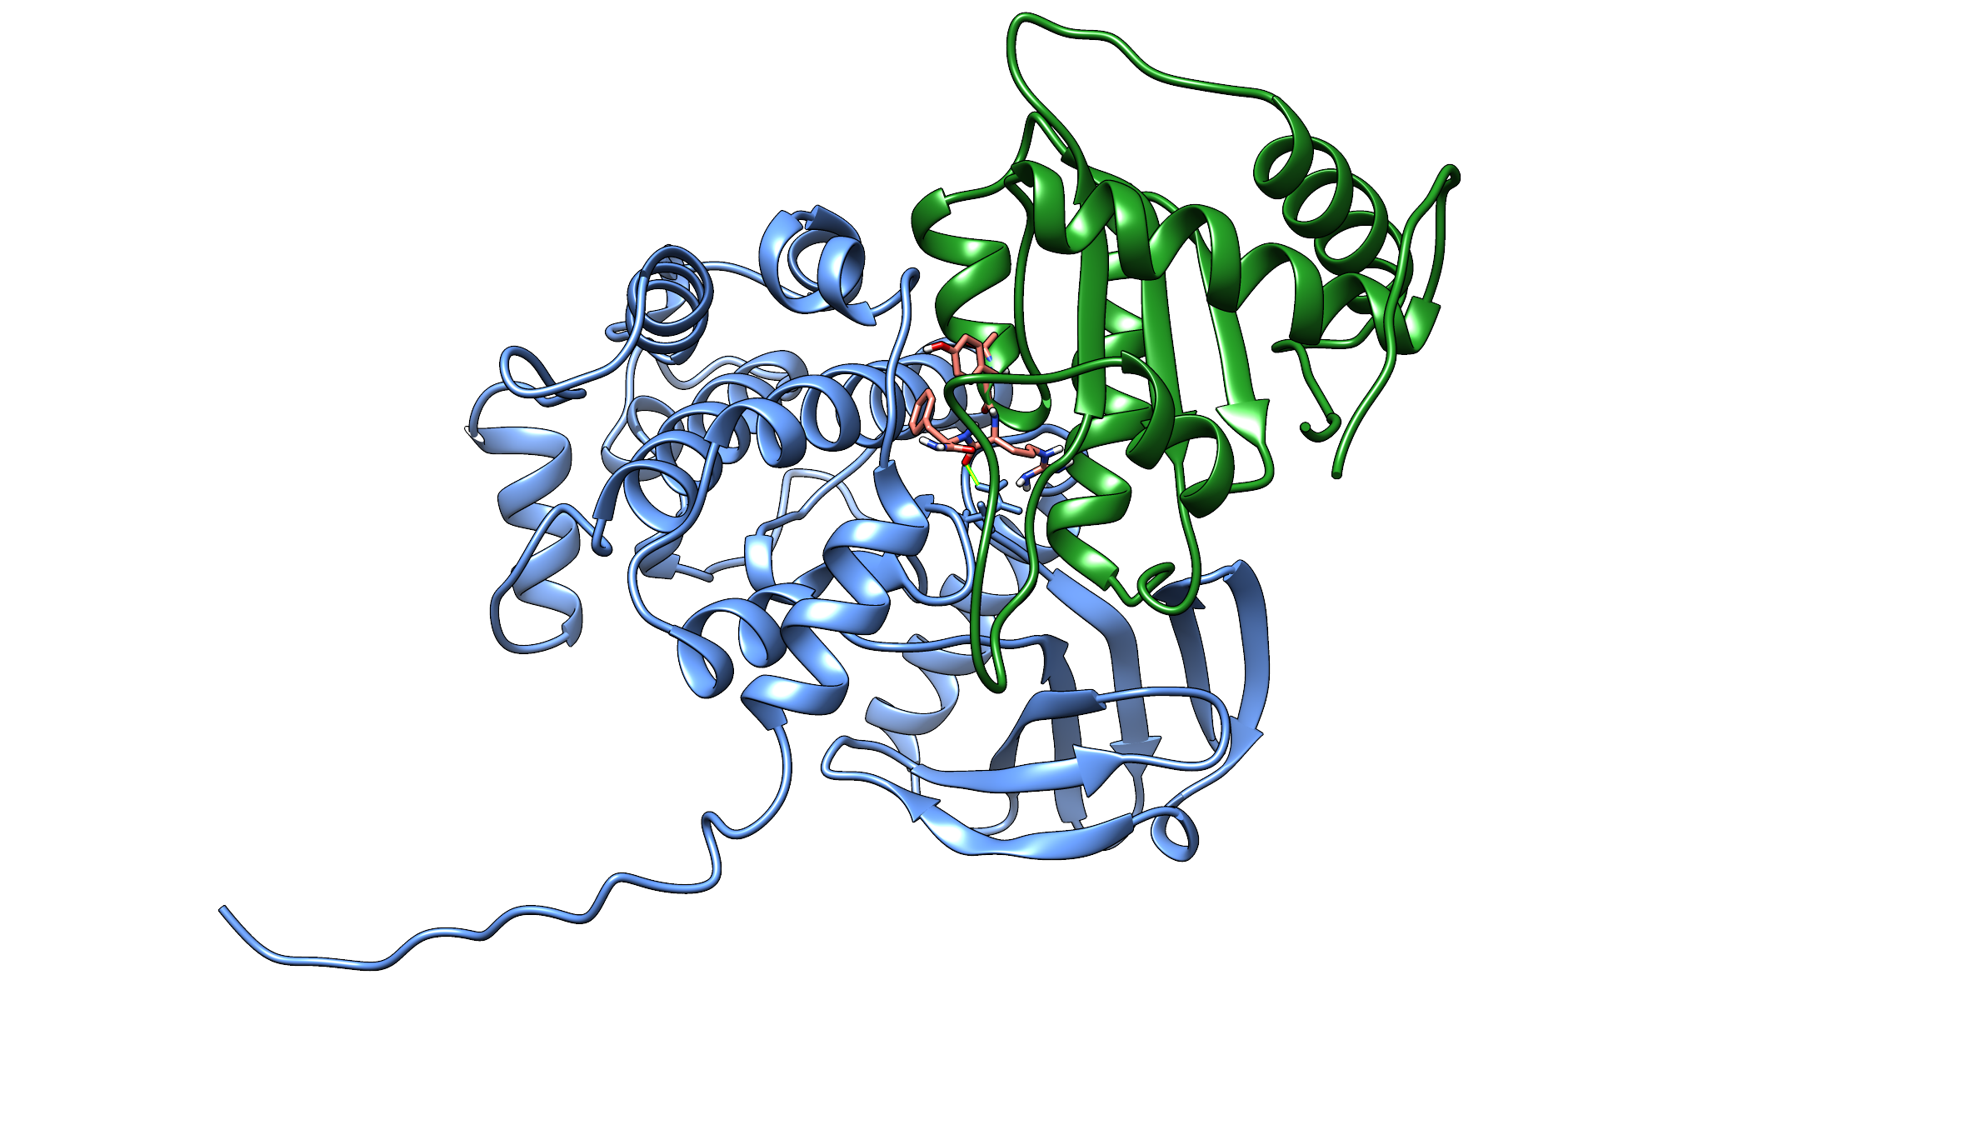

***That's all folks!***

If you liked the workshop and would like to do research using structural bioinformatics approaches contact me (Anna Reymer, email: anna.reymer@gu.se) and we'll find something out.